Call for Papers

Difference: Fascination, Fear and Foreignness

University of Glasgow
College of Arts
5th International PG Conference
24th and 25th May 2016
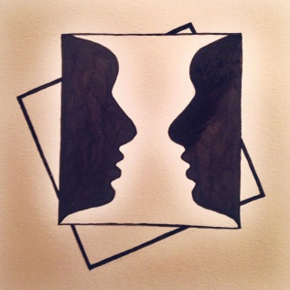
It seemed to her such nonsense – inventing differences, when people, heaven knows, were different enough without that.
Virginia Woolf

The College of Arts, University of Glasgow, invites proposals for papers on the theme of 'Difference' for its fifth international, interdisciplinary postgraduate conference, to be held on 24th-25th May 2016.
Difference is both a fundamental part of our everyday lives and a construct relying on complex, contradictory and culturally-loaded notions. Implicit to the definition of difference is the idea that an entity is 'not like us' or deviates from our notion of what is 'normal'. Difference may be conceptualised positively or negatively - as a fascinating phenomenon that can be assimilated, or as a threat to existing ways of life, and can therefore be both a bridge and a barrier to human interaction.
We welcome proposals, including papers from individual scholars and inter-disciplinary collaborations, that seek to address the overarching theme of difference across the spectrum of Arts and Humanities research. Potential sub-topics can include, but are not limited to:
- Historical conceptualisations of difference: shifting definitions and the construction of difference and hegemony
- Gender and sexuality
- Race, religion, ethnicity and nationality
- Differences across time, space and civilisations
- The creation of the 'other'
- Celebration and persecution of difference
- Health and disease in literature, particularly mental health
- Methodological differences within or across disciplines in the Arts
- Linguistic difference, particularly the concepts of language contact, language variation and minority languages
- Literary and artistic difference

Postgraduates are invited to submit abstracts of 200-300 words via email to artspgconference16@gmail.com by the 5th February 2016.
The conference will also feature the first UK screening of ‘The Mask We Live In’, a film exploring American ideas of hegemonic masculinity and its effect on young men, from the producers of Miss Representation.

