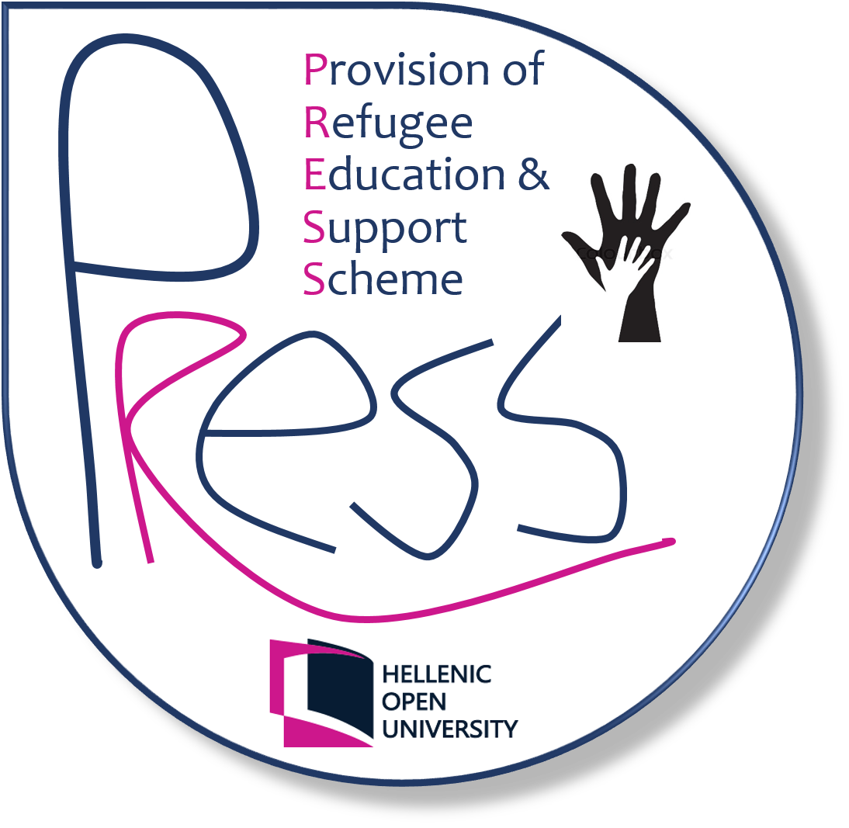
Call for applications for three (3) full-time research positions in Sociolinguistics (Project PRESS, Hellenic Open University)

Description of the position
Project PRESS: Provision of Refugee Education and Support Scheme, an initiative of the Hellenic Open University, is offering three (3) full-time research positions in the subject: fieldwork on the educational (comminication and linguistic) needs of refugees. The positional involves at least 6 months fieldwork in refugee camps in Greece (Lesvos, Thessaloniki or Athens). Contract duration: 9 months.

Required qualifications
Candidates should possess the following qualifications: a) PhD in sociolinguistics or PhD candidates in the same field b) fieldwork experience of conducting research on a refugee/ immigrant community.

How to apply
Applicants are invited to submit the form in Annex A and a detailed CV to: project_press@eap.gr. Closing date for applications: 14 August 2016. Items/ Documents as referred to CV must be presented upon request.
For further informations on the Project, please visit the website page http://www.press-eap.net/ or send us an email at project_press@eap.gr.

ANNEX Α΄

First Name : ……………………………………………………………….
Last Name : ……………………………………………………………….
Address : ……………………………………………………………….
Telephone number: ……………………………………………………………….
Ε-mail: ………………………………………………………………

To: Project PRESS
PROPOSAL
In response to your invitation, I hereby express my interest for the position of field researcher. Please find attached a detailed CV.
Any other supporting documents as referred to CV will be presented upon request.
Date: …./…../2016

